# CS 255 System Design Document Template

This template lays out all the different sections that you need to complete for Project Two. Each section has guidance to prompt your thinking. You will need to continually reference the interview transcript as you work to make sure that you are addressing your client’s needs. There is no required length for the final document. Instead the goal is to complete each section based on what your client’s needs are. Remove this note when you are finished, and replace all bracketed text with the relevant information.

## UML Diagrams

### UML Use Case Diagram

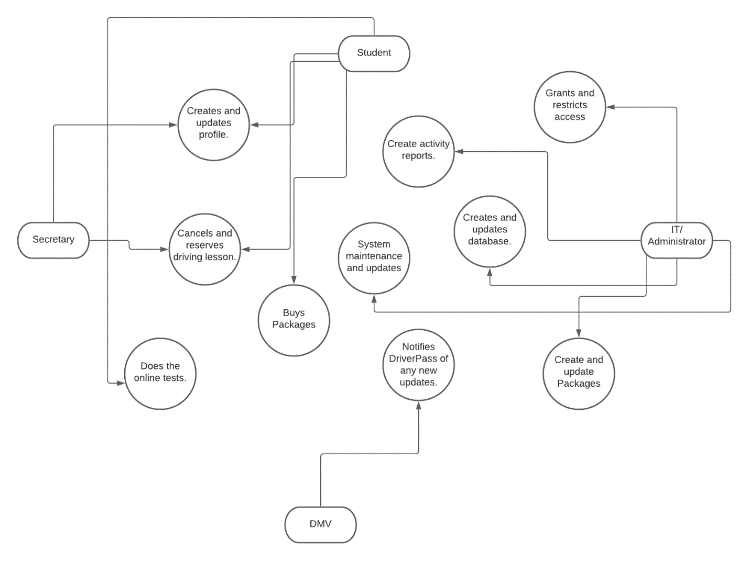

### UML Activity Diagrams

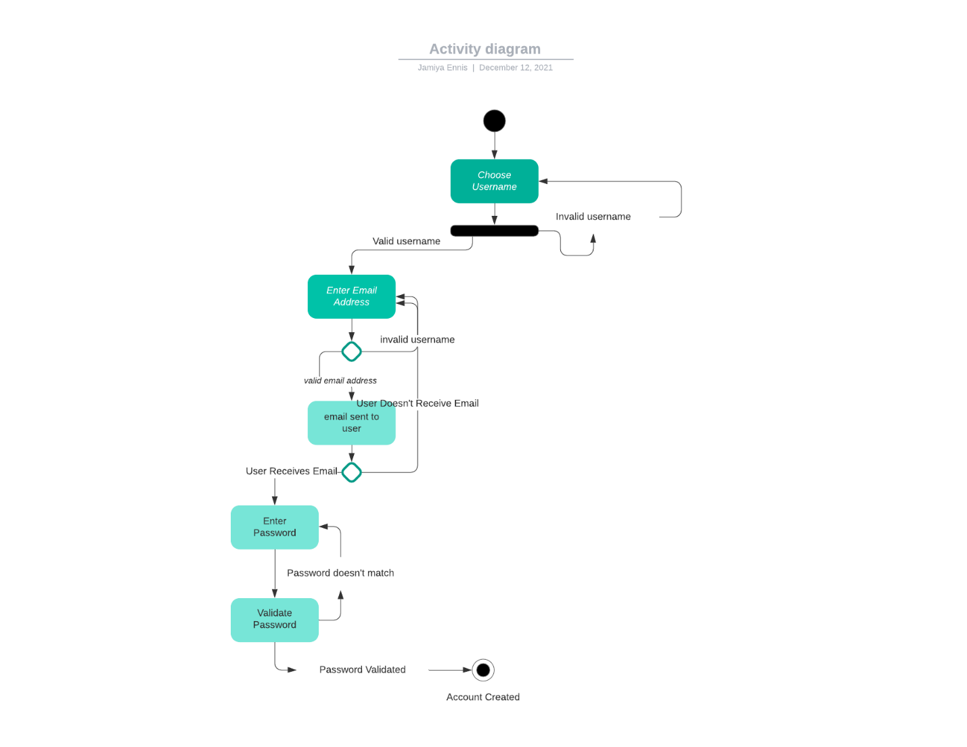

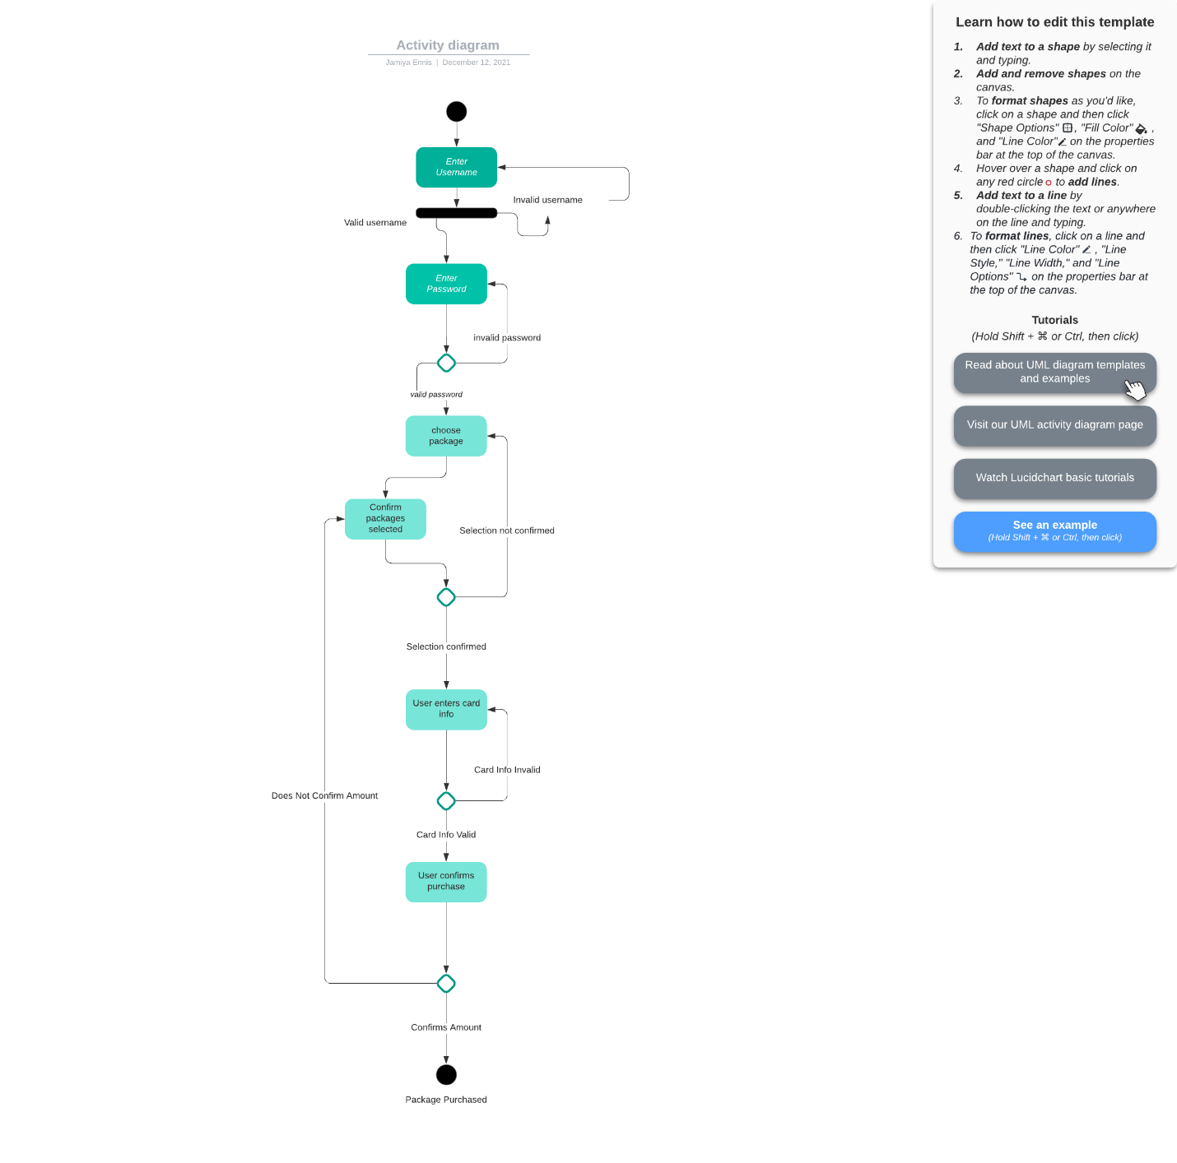

### UML Sequence Diagram

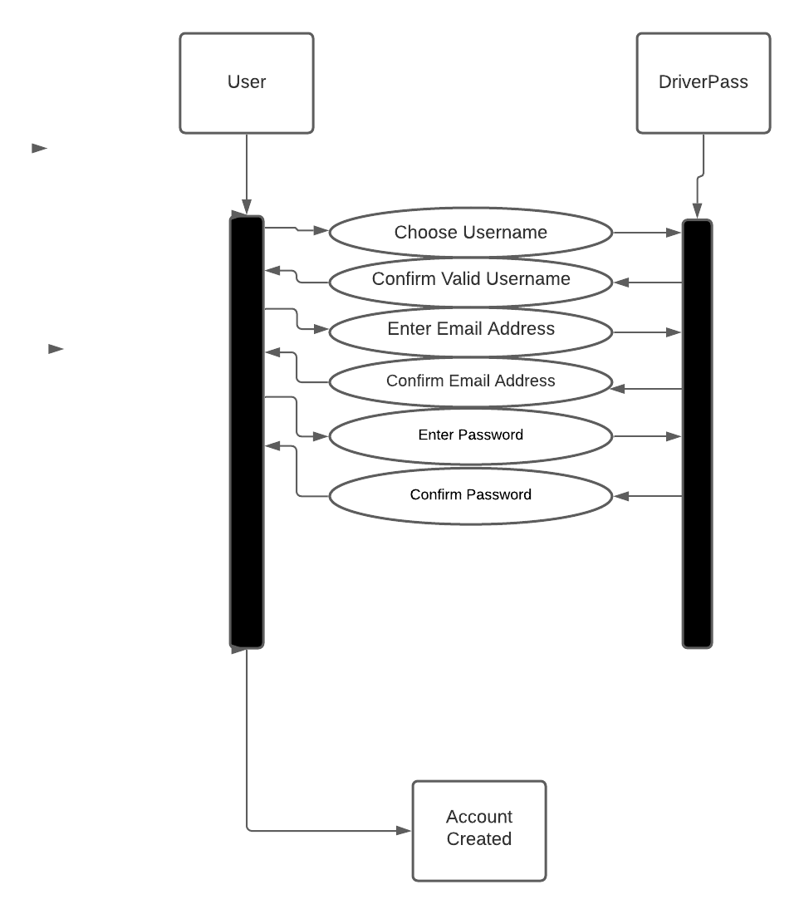

### UML Class Diagram

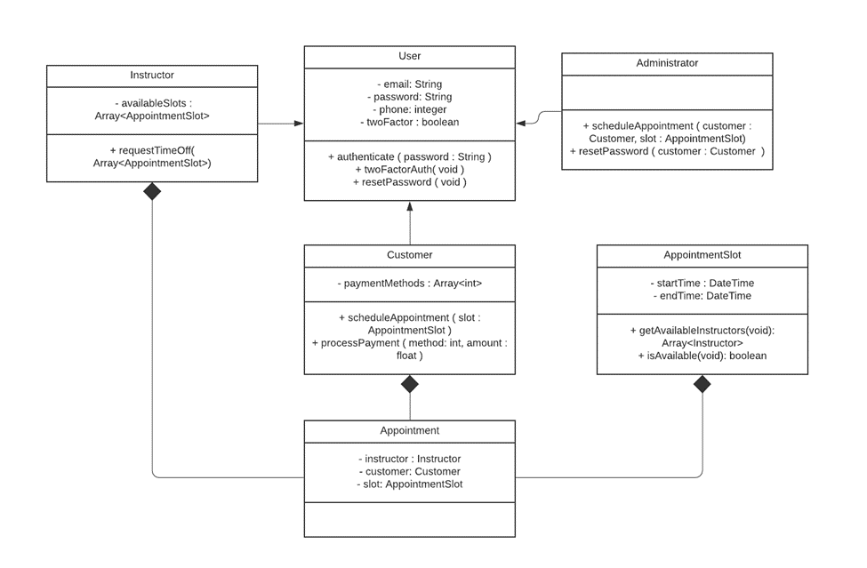

## Technical Requirements

We'll need to create a web-based system that uses the cloud, as well as a mobile version for the owner to view downloaded data on the move, and a database management system for DriverPass to keep track of all clients. In addition, the system will require adequate security measures, such as ensuring that user passwords are case sensitive and encrypted. Because the app would contain sensitive information such as card numbers, phone numbers, and addresses, the system will also require a password reset system to ensure that outsiders cannot access users' accounts. All major operating systems, including Android, iOS, macOS, Windows, and Lenox, should be able to use the system.